**Forest & Bird Talk by *Glenda Rees*, passionate Wildlife Photographer**

Title: ***Featuring the critically endangered Pukunui, Southern New Zealand Dotterel & Other Birds.***

**From 7.30pm Tuesday 17 September 2024 at Holy Trinity Anglican Church, cnr King & Antrim Sts, Windsor, Invercargill.**

**plus Zoom link option:-**

<https://us02web.zoom.us/j/82460403318?pwd=THVIR3cyRDJxNDJLYWZCSFlsRWt2UT09>

Meeting ID: 824 6040 3318

Passcode: 593135

Contact: Jenny Campbell, 027 351 0180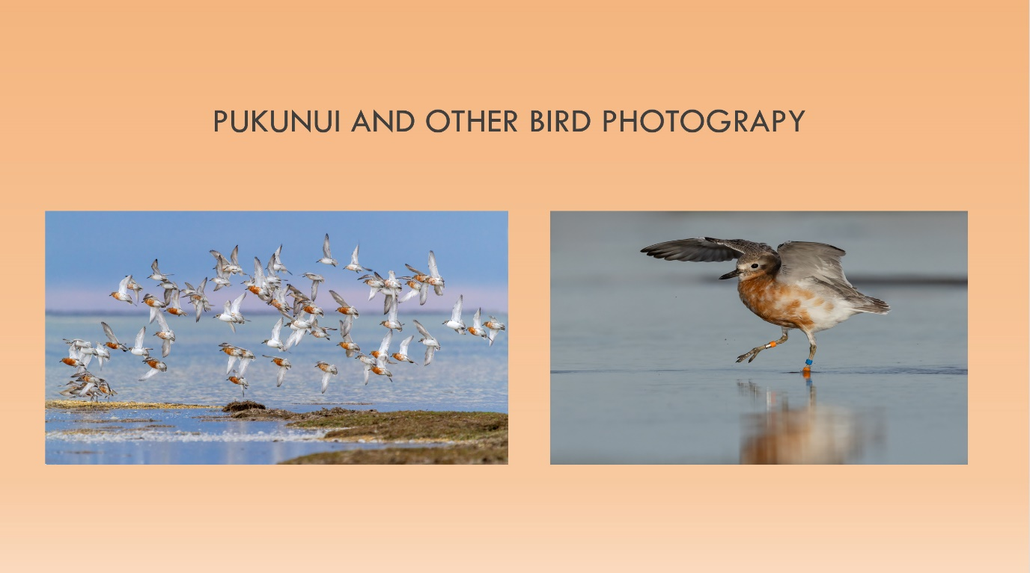

Glenda first became interested in bird photography in 2010 following camping trips to Namibia and South Africa.

Glenda first encountered Pukunui, Southern New Zealand Dotterel in 2011 and ever since, has not missed a winter season with them and even formed a special bond with many of them.  She has witnessed the mainland (Southland) flock drop from about 80 birds, to 55 in 2023 and sadly only 34 this year.  She has photographed many other species over recent years, but Pukunui Southern New Zealand Dotterel will always be the bird she is most passionate about.

Glenda will share photos of some of her fond memories with Pukunui plus some other shore and bush birds which she has also encountered along the way. Many of these also bring special memories, having had national and international recognition.

Glenda’s photo of three Tawaki Fiordland Crested Penguin, graces the cover and Kohitātea January page of 2025 Te Reo o Te Taiao Forest & Bird Conservation calendar.

Rifleman with prey

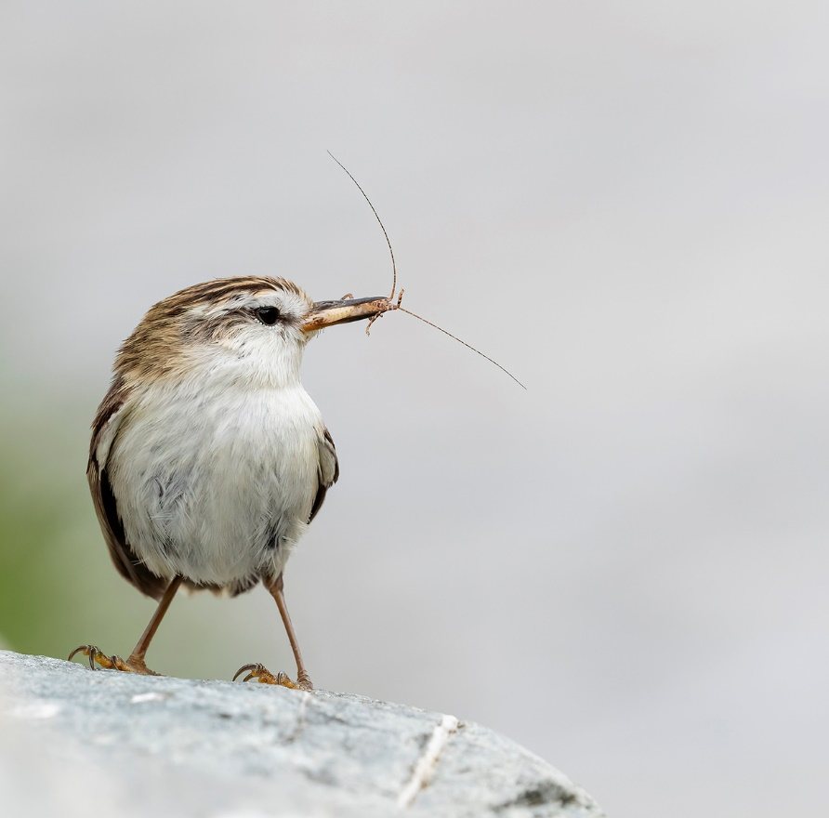

Nesting Rockhopper Penguin